**Lab 4**

**Task 1:**

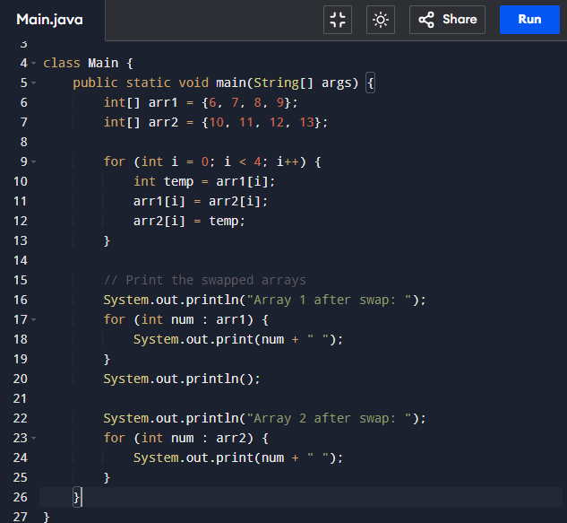

**Output:**

**Task 2:**

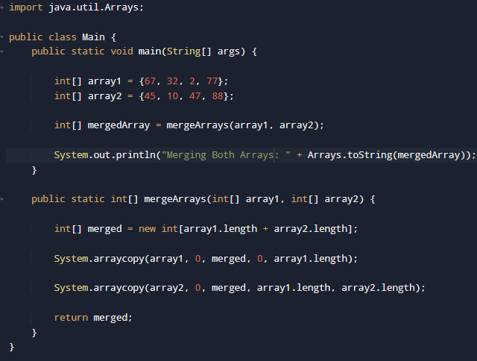

**Output:**

**Task 3:**

**Output:**

**Task 4:**

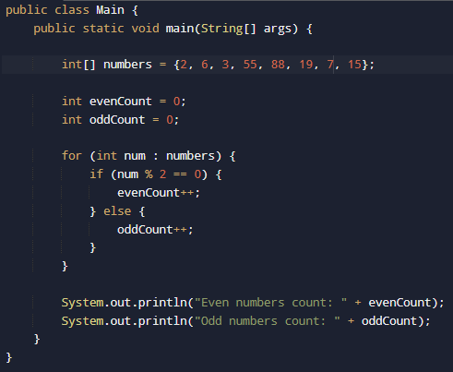

**Output:**

**Task 5:**

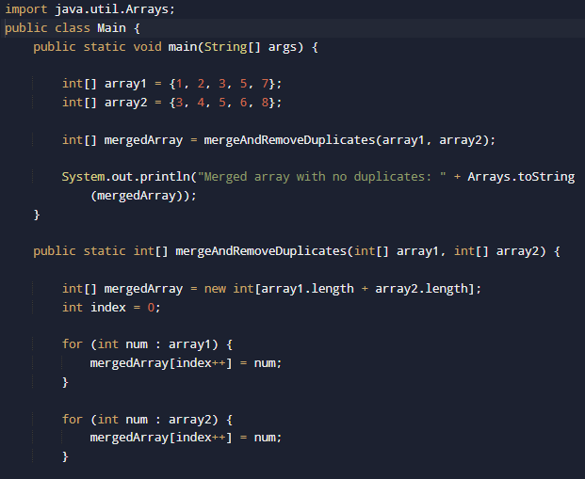

**Output:**

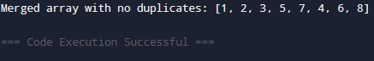

**HomeTasks**

**TASK :**

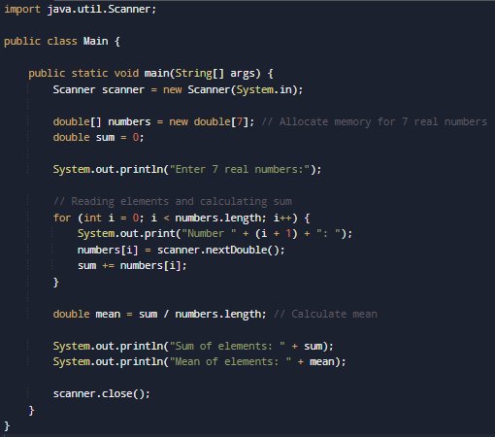

**Output:**

**TASK :**

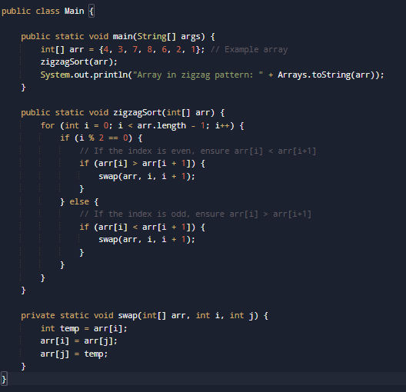

**Output:**

**TASK:**

**Output:**

